**Lab02: Querying the Tables**

**Exercises**

Using StudentInformation database, formulate the following queries:

1. Select all theory based courses that belong to computer science program from course table.

Query:

select * from Course where CreditHrsTheory is not Null

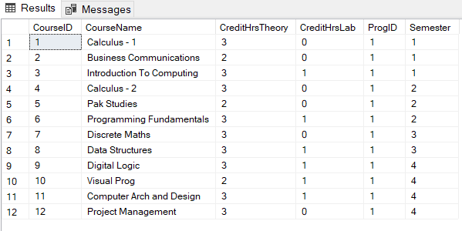

1. List name of all students whose name starts with letter ‘S’.

Query:

select StdName from Std where StdName like 's%'

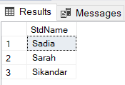

1. Display Name and designation of teachers whose manager is empty.

Query:

select teacherName,Job from teacher where manager is null

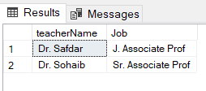

1. Display names of all students that end with alphabet ‘S’.

Query:

select StdName from Std where StdName like '%s'



1. Show name, salary, job of those faculty who are not visiting and job is not J. Lecturer

Query:

select TeacherName,BasicSalary,Job from Teacher where Status != 'Visiting' and Job != 'J.Lecturer'

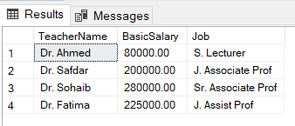

1. Show all students whose name don’t start with letter ‘M’, ‘A’ and ‘R’.

Query:

select * from Std where StdName like '[^mar]%'

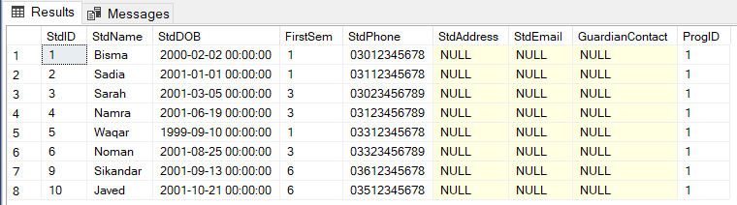

1. Show names of those students whose name starts with ‘A’ and ends with ‘S’.

Query:

select Stdname from std where stdname like 'a%s'



1. Display the list of Faculty names that have letters ‘SA’ in their names.

Query:

select TeacherName from Teacher where TeacherName like '%sa%'

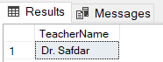

1. Display all students along with their semesters they are in, (from semester 3-6.)

Query:

select * from Std where FirstSem between '3' and '6'

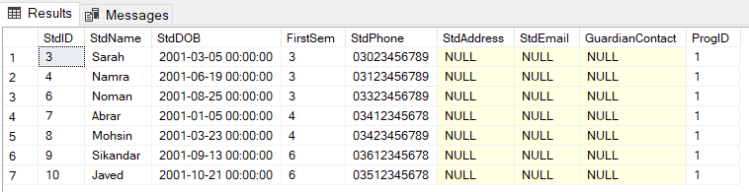

1. Display all faculty with respect to their salaries such that the highest salaried faculty comes first than next highest and so forth.

Query:

select * from teacher order by BasicSalary desc

